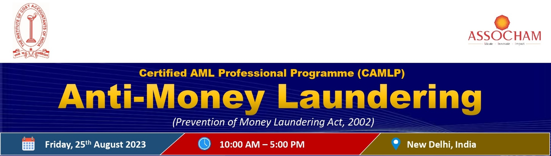
REGISTRATION FORM
I/ we would like to attend/ nominate the following:
 | Delegate 1 | Delegate 2 | Delegate 3
Name
Designation
Name of Organization
GST No. of Organization
Address
Tel #
Mobile #
Email
*ICMAI Membership No.
* ASSOCHAM Membership No.

Participation Fee
Fee for Members of ICMAI and ASSOCHAM | ₹ 5,000.00 + GST (18%) = ₹ 5,900.00
Fee for Non-Members | ₹ 7,500.00 + GST (18%) = ₹ 8,850.00

Award of 4 CEP Credit Hours for ICMAI members
* Credit hours will be awarded to the participant who will attend all the sessions.

METHOD OF PAYMENT | PAYMENT DETAILS
For NEFT/Online payment details:
Bank: HDFC Bank Limited
Address: 4/48, Malcha Marg Shopping Complex Chanakyapuri,
New Delhi -110021
Saving Account No. 05031110000062
IFSC CODE: HDFC0004711

DD/Cheque in favour of ASSOCHAM payable at New Delhi
- Fee once paid is non-refundable, although change of nomination is allowed under the same category.
- Prior Registration is essential. Please email or courier the registration form at the earliest.

Name & Designation of nominating authority (Signature)
Kindly send your ﬁlled-in registration form to:

Mr. Vikash Vardhman Email: vikash.vardhman@assocham.com Contact: +91 90277 88277
CMA Preeti Kothari Email: technical.officer1@icmai.in Contact: +91 11 - 24666199

